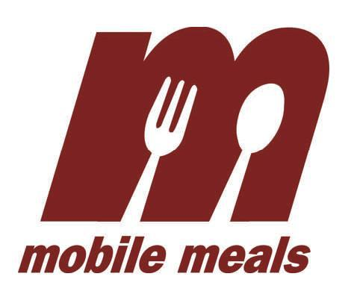

Facts and Figures

Fall 2017

**WHO WE SERVE**

**10%**

**age 85**+

**age 65-74**

**65%**

**For a total of 1,528 clients**

**age <60\***

**age 60-64**



**Our clients say that Mobile Meals has:**

* Helped them stay in their homes and live independently.
* Helped them eat a wider variety of food.
* Improved their health by receiving 5 balanced meals a week.
* Made them feel happier because of volunteer interaction.

**2%**

**Men**

**28%**

**35%**

**30%**

**Women**

**age 75-84**

**30%**

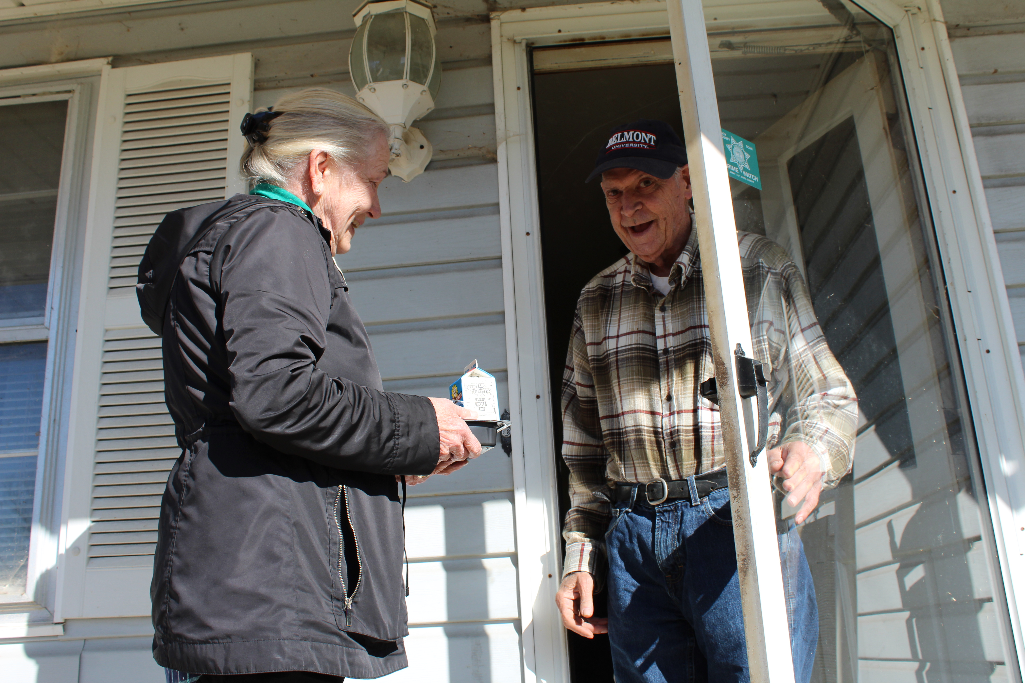

For $884, Mobile Meals can provide:

ONE YEAR of meals, less than the cost of

ONE WEEK in a nursing home or

ONE DAY in the hospital

**HOLIDAY SUPPORT**

We deliver meals both Thanksgiving and Christmas Day. We also distribute holiday gifts donated by our community.

**DAILY SAFETY CHECKS**

Daily meals also ensure that someone is checking on our clients every day. We verify that anyone who does not answer his/her door is safe and sound.

**HOME ASSESSMENTS**

Each client receives an annual home assessment, where a trained professional checks for any health or safety hazards.

**WHAT MAKES MOBILE MEALS DIFFERENT?**

saving us over

**$1,300,000**

a year

travel

**100**

volunteers a day

on

**1,500**

miles across all of Knox County

**68\***

routes

**We need your help**

Mobile Meals needs:

* Volunteers to deliver meals Mon-Fri 10am-noon
* Groups to pack emergency meal boxes/food bags
* Help with special projects, including our annual "Power of the Purse" fundraiser
* Connecting Hearts - weekly home visits (6 month commitment)

**Contact our volunteer coordinator at shelly.woodrick@knoxseniors.org**

*paid staff deliver a few routes in challenging or extremely rural areas

(865)524-2786 | PO Box 51650, Knoxville TN 37950-1650 | www.knoxseniors.org/mobile

Knox County Mobile Meals @KnoxOOA @KnoxMobileMeals

*We serve the disabled children under 60 of qualifying Mobile Meals clients